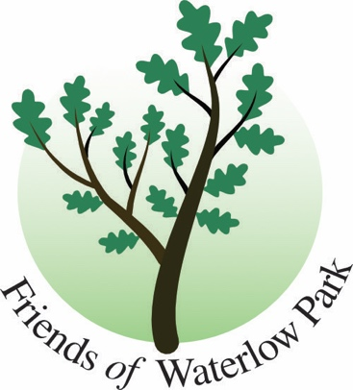
DATE FOR THE DIARY
Friends of Waterlow Park Annual General Meeting 2025
WEDNESDAY 11 JUNE 2025. Refreshments 6.30. AGM 7.00 – 8.30pm.
LUX, Waterlow Park Centre, Dartmouth Park Hill, N19 5JF.
Keynote Speaker: Jeffrey G Duckett Emeritus Professor of Botany

Everything Green in Waterlow Park
This presentation will capture the bosky delights of Waterlow Park through the seasons from the biggest trees to the diminutive mosses growing on them. Jeff will review the past history of the park in relation to other woody places in London and also look to its future in the context of climate change.
Emeritus Professor Jeffrey G Duckett, PhD Cantab, FLS, FZS is a Research Associate at the Natural History Museum, recipient of the 2008 Linnean Society medal for Botany and an honorary member of the British Bryological Society. His research, on the conquest of land by plants, has taken him to six continents. Since the Clean Air Acts, 1956 and 1968, he has been studying the effects of air quality on London’s environment. He regularly leads botanical excursions all over London.
Followed by
* A snapshot of the Friends’ year on social media
* Report from the Waterlow Park Trust Advisory Group
* AGM Reports
Editors: Contact fiona.brown944@gmail.com

