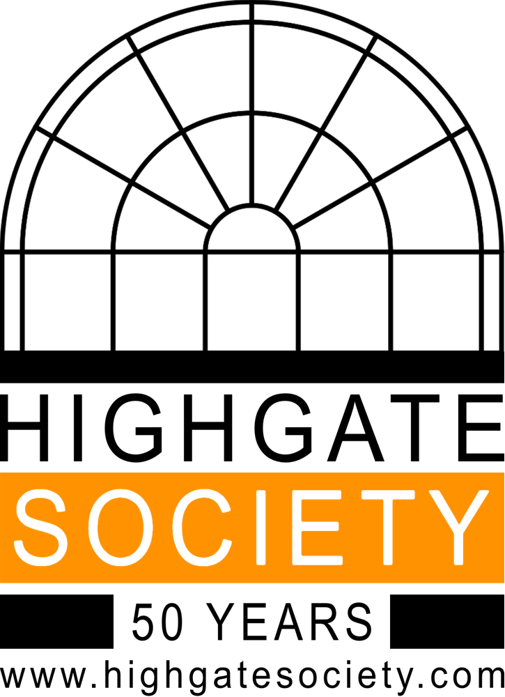

10A SOUTH GROVE

HIGHGATE

LONDON

N6 6BS

**Is Buzz the Biz? ............**

Buzz, our magazine, is required print

reading for a community that cares about their Highgate.   
  
🐝We want to discuss the direction of buzz, so we propose a discussion forum to be held on **Wednesday 16 November**and

**Wednesday 30 November at 8pm**

10A South Grove N6 6BS for an hour.  
  
🐝Please join us, and share your thoughts on how we can progress this valuable journal.