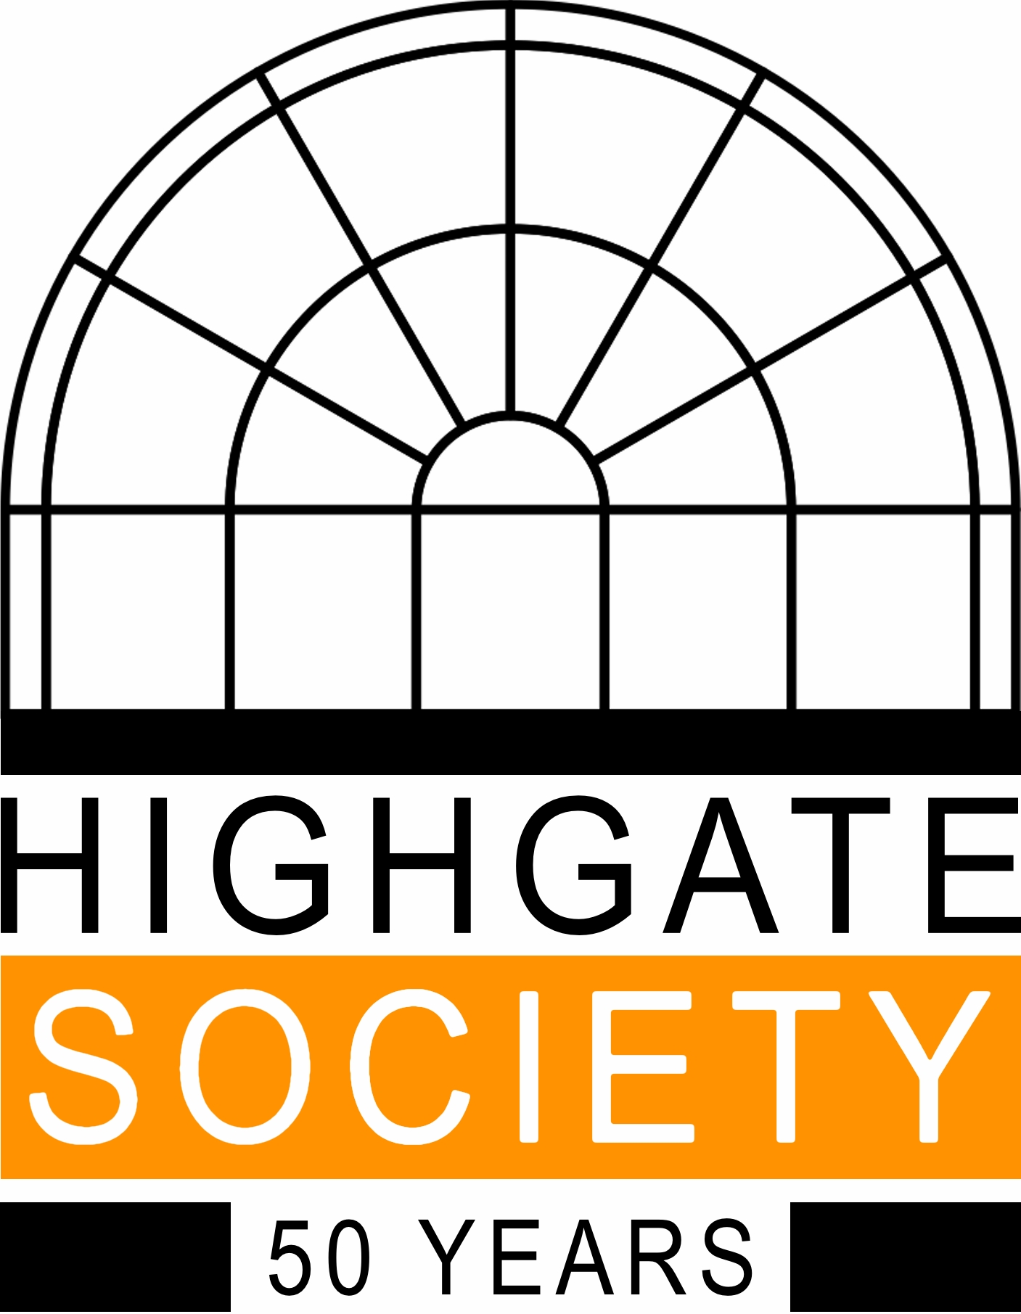

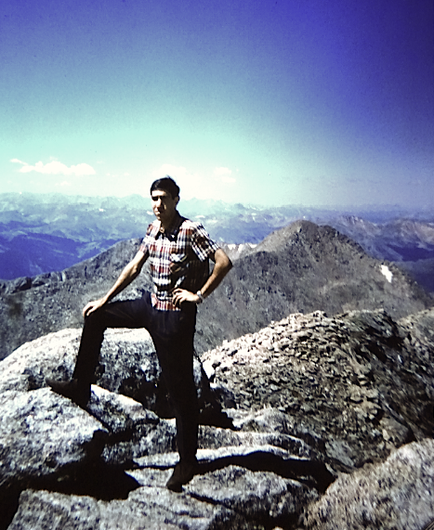
‘A YOUNG MAN
GOES WEST’

Other things were happening in 1966. Michael Hammerson, totally oblivious of the birth of the Highgate Society, went on his student trip to America, covering 15,000 miles and seeing more of it in three months than many see in a lifetime. 50 years later, as a follow-up to talks given earlier in the year by Catherine Budgett-Meakin and Richard Webber, about their more recent visits to America, he will reminisce about that memorable journey in an illustrated talk.
Sunday November 13, 2016, 3.30 p.m.
at 10a South Grove.
